Exercise "Absorption 1"
Slide 21 shows schematically how absorption coefficients of molecules are measured. These methods are well established since more than hundred years (Plank carried out his first spectroscopic measurements in 1900 in his basement.) Discuss what is the "reference" spectrum in the sketch below, and how could you improve the "reference" spectrum for determining the molar absorption coefficient of a compound dissolved in a solvent in the lower part of the sketch.
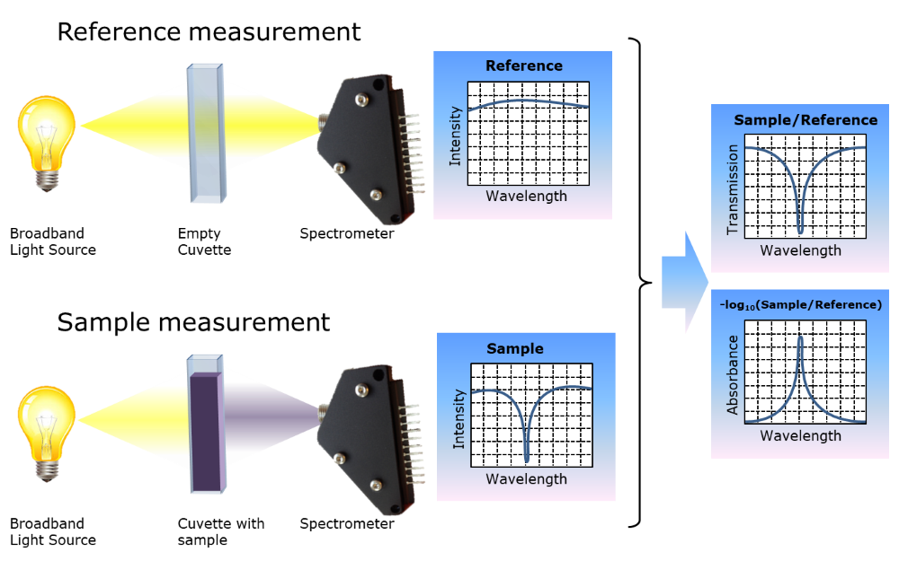
Exercise "Absorption 2"
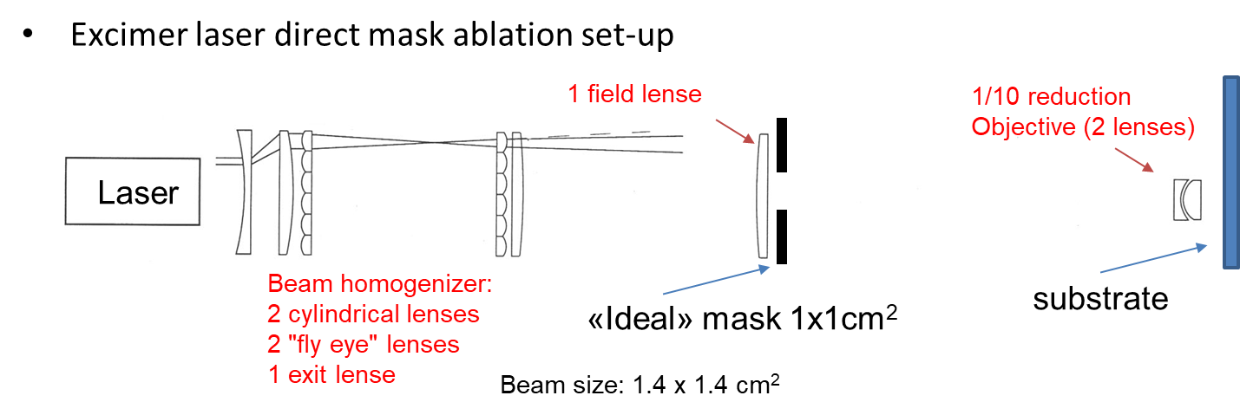
Calculate the laser fluence (mJ/cm²) and the power during the laser pulse of 19 ns duration of the projection mask direct ablation system.
Materials properties: α _{Quartz (fused silica), 193nm} = 3.9586 m⁻¹
α _{air, 193nm} = 0.7440 m⁻¹
Reflection per interface (bad AR coating): 1.8 %
Geometries: Total thickness of all fused silica lenses: 31.5 mm
Total distance between laser exit and substrate : 2.4685 m
Laser parameters: Fluence per pulse: 200 mJ
Pulse duration: 19 ns
Excercise "Absorption 3"
Sending ArF Excimer laser light (193nm wavelength) through 1 meter air at 1 atm pressure (lab conditions), 50% reduction of measured light intensity is observed. Particle filtering does not change the result. Air temperature, that changes relative humidity does almost not change the result neither. Dry air does not change neither. Sending the light through a tube filled or purged with Ar or N₂ results in no decrease of the intensity after 1 meter any more.
How do you explain this observation?
- Which gas interacts at 193 nm wavelength?
- What happens at 157nm Excimer (F₂ Excimer – laser) in air?
- What happens at 13.2 nm wavelength?

